Name: Date: Period:

El Niño

El Niño is a change in global weather patterns that happens periodically when the ocean water southern Pacific Ocean gets warmer than normal. This causes trade winds that normally blow east to west to weaken. El Niño develops every 2 to 7 years and will peak in the Northern Hemisphere’s winter. Fishermen in Peru coined the term El Niño in 1880 to describe the occasional flow of warm waters from the equator. Since this phenomenon usually happened around Christmas time, they named the event “The Little Boy” or “El Niño” in reference to the birth of Jesus Christ.

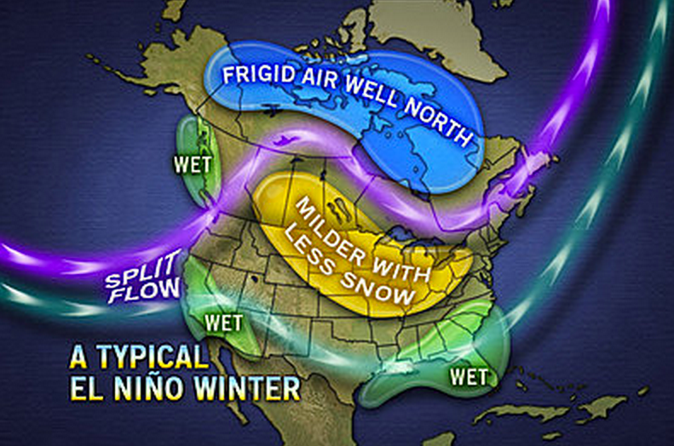
El Niño can be helpful or harmful, and sometimes even both in the same place. The impact of El Niño is often most severe in Peru and surrounding countries in South America. The abnormally warm water causes record-breaking rain. This often causes deadly floods in this region. In places such as Australia and Indonesia, El Niño can lead to a fierce drought that reduces crop yields and decreases hydropower. El Niño brings more precipitation to places like California and the southern United States. This can be a big help if those places have experienced droughts recently. On the other side, too much rain can cause flooding and major mudslides. El Niño causes winter temperatures in the northern United States to be warmer than average with less snow. This reduces heating bills and energy use. The map to the right shows the typical conditions in the United States during an El Niño.

The strength of El Niño depends on how warm the waters off the coast of South America are. The last massive El Niño was in 1997-1998. It caused an estimated $35 billion and 23,000 deaths around the world. Based on current data, the 2015-2016 El Niño could be just as strong, or stronger than the 1997-1998 event. Scientists predict that future El Niño events could be stronger also due to the increase in global temperature due to global warming.

Vocabulary

Word | Definition | Drawing
Trade Winds
ENSO
Southern Oscillation
Thermocline
Greenhouse Effect
Upwelling

- What is El Niño?

- Why would El Niño peak when it is winter in the Northern Hemisphere?

- State one positive effect of El Niño for people who live in New York.

- State one negative effect of El Niño for people who live in New York.

Base your answers to questions 5 through 9 on the maps and passage below. The maps show difference in trade wind strength, ocean current direction, and water temperature associated with air-pressure changes from normal climate conditions to El Niño conditions.

El Nino Conditions

El Nino conditions occur with a build up of warm water in the equatorial Pacific Ocean off the coast of South America. The immediate cause of this buildup is a change in air pressure that weakens the southern trade winds. These are the planetary winds that move air from 30˚S to the equator. Normally, these strong, steady winds, with the help of their counterparts in the Northern Hemisphere, push equatorial water westward away from South America. But, at intervals of two to seven years, these winds weaken, causing the westward water flow to reverse. This results in the accumulation of unusually warm water on the east side of the equatorial Pacific Ocean. This warm water not only changes the characteristics of the air above it, but it is also thought to be the cause of weather changes around the world. El Nino conditions may last only a few months, but often last a year or two.

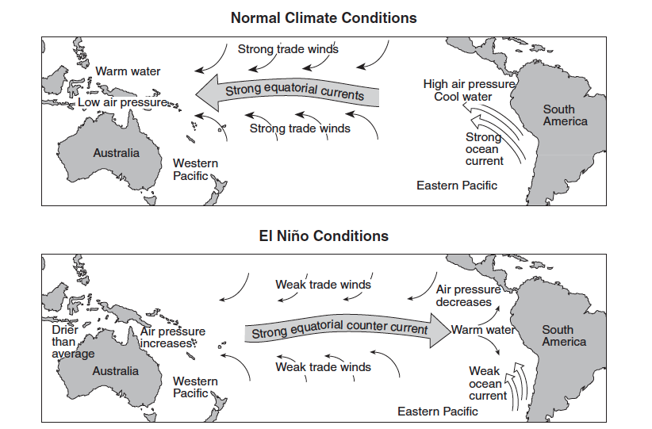

- Which natural event temporarily slows or reverses surface ocean currents in the equatorial region of the Pacific Ocean, causing a disruption of normal weather patterns?
  - monsoons c. El Niño
  - volcanic eruptions d. deforestation

- Under normal climate conditions, what are the characteristics of the surface ocean current that flows along most of the west coast of South America?
- cool water moving toward the equator
- cool water moving away from the equator
- warm water moving toward the equator
- warm water moving away from the equator

- During an El Niño event, surface water temperatures increase along the west coast of South America. Which weather changes are likely to occur in this region?
- decreased air temperature and decreased precipitation
- decreased air temperature and increased precipitation
- increased air temperature and increased precipitation
- increased air temperature and decreased precipitation

- The trade winds between 30˚S and the equator usually blow from the
- northeast c. northwest
- southeast d. southwest

- Equatorial Pacific trade winds weaken during El Niño conditions when air pressure
- falls in the western Pacific and rises in the eastern Pacific
- falls in both the western and eastern Pacific
- rises in the western Pacific and falls in the eastern Pacific
- rises in both the western and eastern Pacific

Base your answers to questions 10 through 15 on the two cross sections below, which represent the Pacific Ocean and the atmosphere near the Equator during normal weather (cross section A) and during El Niño conditions (cross section B). Sea surface temperatures (SST) are labeled and trade-wind directions are shown with arrows. Cloud buildup indicates regions of frequent thunderstorm activity. The change from normal sea level is shown at the side of each diagram.

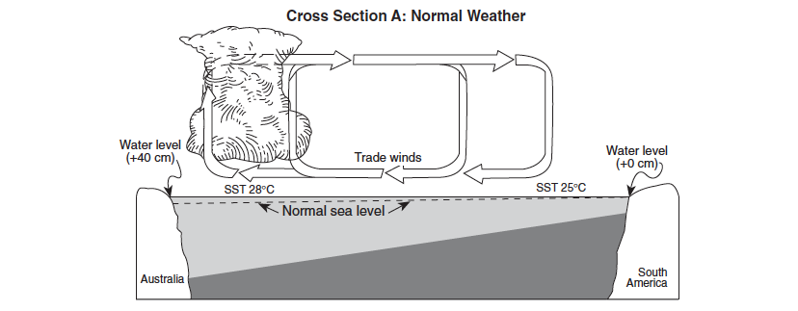

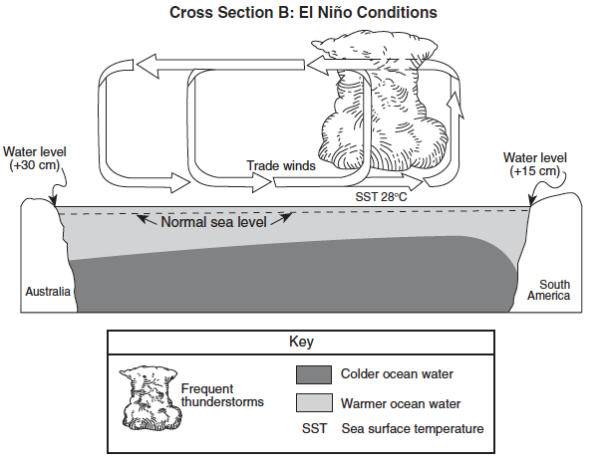

- Which statement correctly describes sea surface temperatures along the South American coast and Pacific trade winds during El Niño conditions?
  - The sea surface temperatures are warmer than normal, and Pacific trade winds are from the west.
  - The sea surface temperatures are warmer than normal, and Pacific trade winds are from the east.
  - The sea surface temperatures are cooler than normal, and Pacific trade winds are from the west.
  - The sea surface temperatures are cooler than normal, and Pacific trade winds are from the east.

- Compared to normal weather conditions, the shift of the trade winds caused sea levels during El Niño conditions to
- decrease at both Australia and South America
- decrease at Australia and increase at South America
- increase at Australia and decrease at South America
- increase at both Australia and South America

- During El Niño conditions, air above the Pacific Ocean moving over the land on the equatorial west coast of South America is likely to be
- cooler and drier than usual c. warmer and drier than usual
- cooler and wetter than usual d. warmer and wetter than usual

- During El Niño conditions, thunderstorms increase in the eastern Pacific Ocean region because the warm, moist air is
- less dense, sinking, compressing and warming
- less dense, rising, expanding, and cooling
- more dense, sinking, compressing, and warming
- more dense, rising, expanding, and cooling

- During El Niño conditions, thunderstorms decrease in the western Pacific Ocean region because the cold, dry air is
- less dense, sinking, compressing and warming
- less dense, rising, expanding, and cooling
- more dense, sinking, compressing, and warming
- more dense, rising, expanding, and cooling

- The development of El Niño conditions over this region of the Pacific Ocean has caused
- changes in worldwide precipitation patterns
- the reversal of Earth’s seasons
- increased worldwide volcanic activity
- decreased ozone levels in the atmosphere

