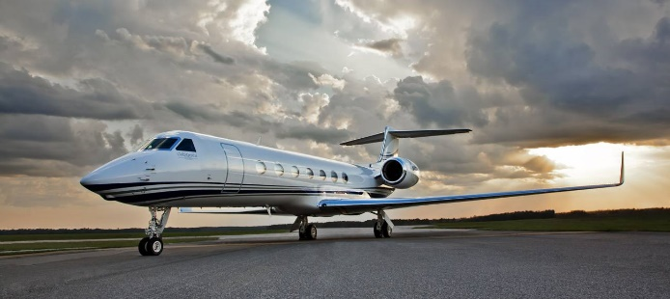
The Gulf Stream Explained
https://www.youtube.com/watch?v=UuGrBhK2c7U
- What is the conveyor belt called?

- Thermo means?

- Haline means?

- Describe what occurs at the equator that changes the density.

- What is the main property of water that causes it to move?

- The Gulf Stream moves toward __________________________________________.

- Trade winds blow warm water to ______________________________________________________.

- What “splits” the west winds?

- What are “chimneys”?

- What/who travels on the Gulf Stream?

- What would the melting of the polar ice caps do to the density of the water?

- How would this positive feedback loop affect the Gulf Stream?

