Name: _______________________________________ Date: ______________ Period: __________

The Earth's Atmosphere

The atmosphere surrounds Earth and protects us by blocking out dangerous rays from the sun. The atmosphere is a mixture of gases that becomes thinner until it gradually reaches space. It is composed of Nitrogen (78%), Oxygen (21%), and other gases (1%).

Oxygen is essential to life because it allows us to breathe. In addition, some of the oxygen has changed over time forming ozone. The ozone layer filters out the sun's harmful ultraviolet radiation. Recently, there have been many studies on how humans caused a hole to develop in the ozone layer.

Humans are also affecting Earth's atmosphere through the greenhouse effect. Due to increases in gases, such as carbon dioxide, that trap heat being radiated from the Earth, scientists believe that the atmosphere may have problems balancing the incoming solar radiation and the reradiated heat from Earth's surface creating the greenhouse effect.

The atmosphere is divided into five layers depending on how temperature changes with height.
Most of the weather occurs in the first layer.

Layers of the Earth's Atmosphere

The atmosphere is divided into five layers. It is thickest near the surface and thins out with height until it eventually merges with space.
- The troposphere is the first layer above the surface and contains half of the Earth's atmosphere. Weather occurs in this layer.
- Many jet aircraft fly in the stratosphere because it is very stable. Also, the ozone layer absorbs harmful rays from the Sun.
- Meteors burn up in the mesosphere.
- The thermosphere is a layer with auroras. It is also where the space shuttle orbits.
- The atmosphere merges into space in the extremely thin exosphere. This is the upper limit of our atmosphere.

The Troposphere

The troposphere is the lowest region of the Earth's atmosphere, where masses of air are very well mixed together and the temperature decreases with altitude. At the top of the troposphere, the temperature is about -60°C.The air is heated from the ground up because the surface of the Earth absorbs energy and heats up faster than the air. The heat is mixed through the troposphere because on average the atmosphere in this layer is slightly unstable. Weather occurs in the Earth's troposphere. In fact, most clouds form in this layer. This layer reaches an altitude of 16 km.

The Stratosphere

In the Earth's stratosphere, the temperature increases with altitude (as opposed to the troposphere, where it gets colder with altitude). The increasing temperature in the stratosphere is caused by the presence of a layer of ozone near an altitude of 25 kilometers. The lower stratosphere is cold at about -60°C and as altitude increase to the top of the stratosphere it can reach temperatures of -15°C. The ozone molecules absorb high--‐energy UV rays from the sun, which warm the atmosphere at that level. The terrestrial stratosphere is the region between the tropopause, or the end of the troposphere, and the level at which the maximum warming due to the presence of ozone takes place, which is at an altitude of about 50 kilometers.

Ozone

First things first --‐ what is ozone? Ozone is made of three oxygen atoms (O3). The oxygen in our atmosphere that we breathe is made up of two oxygen atoms (O2). Because of its chemical formulation, a single atom of oxygen (O) is unstable. That is, it wants to combine with something else. That is why oxygen is almost always found in pairs, in its (diatomic) form, where it is more stable. (O3) is less stable than (O2), because it wants to return to the diatomic state by giving up an oxygen atom.

About 90% of the ozone in the Earth's atmosphere lies in the region called the stratosphere which is found between 16 and 48 kilometers (10 and 30 miles) above the Earth's surface. Ozone forms a kind of layer in the stratosphere, where it is more concentrated than anywhere else, but even there it is relatively scarce. Its concentrations in the ozone layer are typically only 1 to 10 parts of ozone per 1 million parts of air.

Ozone and oxygen molecules in the stratosphere absorb ultraviolet light from the Sun, providing a shield that prevents this radiation from passing to the Earth's surface. While both oxygen and ozone together absorb 95 to 99.9% of the Sun's ultraviolet radiation, only ozone effectively absorbs the most energetic ultraviolet light, known as UV--‐C and UV--‐B, which causes biological damage. The protective role of the ozone layer in the upper atmosphere is so vital that scientists believe life on land probably would not have evolved --‐ and could not exist today --‐ without it.

The term "shield" as a description of ozone in the stratosphere is a bit misleading because the molecules do not form an impermeable sphere around the Earth. Ozone continuously breaks apart into its oxygen atoms and reforms as ozone molecules, so a particular ozone molecule doesn't last very long. The "shield" changes constantly, but the atmospheric chemical processes maintain a dynamic equilibrium that keeps the overall amount of ozone constant --‐ that is, it would if humans did not contribute to the chemical processes. There is compelling scientific evidence that ozone is destroyed in the stratosphere and that some human--‐released chemicals such as CFC’s are speeding up the breakdown of ozone in the atmosphere.

The Mesosphere

In the Earth's mesosphere, the air masses are relatively mixed together and the temperature decreases with altitude. Atmospheric temperatures reach the lowest average value of around --‐90°C in the mesosphere at the top. At the bottom of the layer is starts at temperatures of -15°C. This is also the layer in which a lot of meteors burn up while entering the Earth's atmosphere. The mesosphere extends from the top of the stratosphere (the stratopause, located at about 50 kilometers) to an altitude of about 90 kilometers. Upper reaches of the atmosphere, such as the mesosphere, can sometimes be detected by looking at the limb of a planet.

The Thermosphere

The Earth's thermosphere is the layer of the atmosphere which is first exposed to the Sun's radiation and so is first heated by the Sun. The air is so thin that a small increase in energy can cause a large increase in temperature. At the bottom of this layer temperatures are around -90°C. The temperature in the thermosphere is very dependent on solar activity. When the Sun is active, temperatures can reach up to 1,500°C or higher! The nitrogen and oxygen here convert solar energy into heat. This layer reaches an altitude of 550 km above the Earth’s surface. Because of the thin air in the thermosphere, scientists can't measure the temperature directly. They measure the density of the air by how much drag it puts on satellites and then use the density to find the temperature. The thermosphere also includes the region of the Earth's atmosphere called the ionosphere. The ionosphere is the region of the atmosphere that is filled with charged particles. Elevated temperatures can sometimes cause a molecule to become ionized, therefore, the ionosphere and thermosphere can overlap.

The Exosphere

At very high altitudes, the atmosphere becomes very thin. The region where atoms and molecules escape into space is referred to as the exosphere. This is the true upper limit of the Earth's atmosphere reaching an altitude of 10,000 km. The exosphere extends from the thermosphere out to space. Satellites orbit in the exosphere. The temperatures at the bottom of the exosphere is around 2,000°C. As you extend further out, the temperatures reach zero because there is very little air to transmit heat.

The Earth’s Atmosphere Activity Name: _________________________________________
Use the information provided, fill in the following chart regarding the layers of the atmosphere.

 | What are the main gases found in the atmosphere? | What is the basis for dividing the atmosphere into five layers? | What is an effect of having an unbalance amount of gases in the atmosphere?
Atmosphere

 | Extend between which Altitudes (km) | Maximum Temperature (°C) | What happens as altitude increases to Temperature | Important Characteristic of the Layer
Troposphere
Stratosphere
Mesosphere
Thermosphere
Exosphere

 | What is it? | Where is it in the atmosphere? | Why is it important?
Ozone Layer

Graphing the Layers of the Atmosphere

Table 1 contains the average temperature readings at various altitudes in the Earth’s atmosphere.

1. Plot this data on the graph on the worksheet, and connect adjacent points with a smooth curve.

Be careful to plot the negative temperature numbers correctly.

This profile provides a general picture of temperature at any given time and place; however, the actual temperature may deviate from the average values, particularly in the lower atmosphere.

TABLE 1
Average Temperature Readings at Various Altitudes
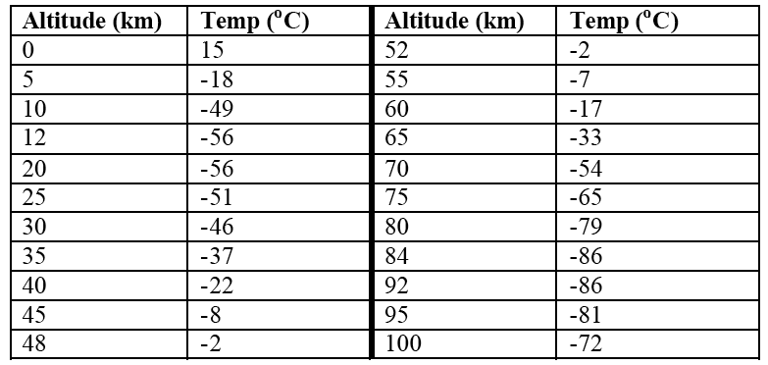

2. Label the different layers of the atmosphere

troposphere
stratosphere
mesosphere
thermosphere
exosphere

3. Mark the general location of the ozone layer.

