Name: _______________________________________________________ Date: ______________ Period: __________

Inter- Intra- Molecular Forces
There are two kinds of forces, or attractions, that operate in a molecule—intramolecular and intermolecular.
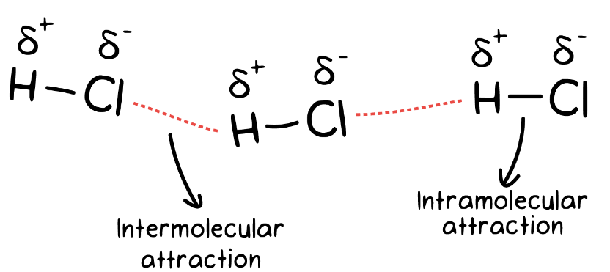
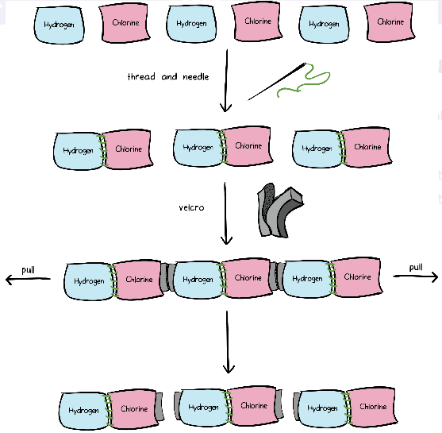
Inter vs Intra We have six towels—three are purple in color, labeled hydrogen and three are pink in color, labeled chlorine. We are given a sewing needle and black thread to sew one hydrogen towel to one chlorine towel. After sewing, we now have three pairs of towels: hydrogen sewed to chlorine. The next step is to attach these three pairs of towels to each other. For this we use Velcro as shown above. So, the result of this exercise is that we have six towels attached to each other through thread and Velcro. Now if I ask you to pull this assembly from both ends, what do you think will happen? The Velcro junctions will fall apart while the sewed junctions will stay as is. The attachment created by Velcro is much weaker than the attachment created by the thread that we used to sew the pairs of towels together. A slight force applied to either end of the towels can easily bring apart the Velcro junctions without tearing apart the sewed junctions. Exactly the same situation exists in molecules. Just imagine the towels to be real atoms, such as hydrogen and chlorine. These two atoms are bound to each other through a polar covalent bond—analogous to the thread. Each hydrogen chloride molecule in turn is bonded to the neighboring hydrogen chloride molecule through a dipole-dipole attraction—analogous to Velcro. We’ll talk about dipole-dipole interactions in detail a bit later. The polar covalent bond is much stronger in strength than the dipole-dipole interaction. The former is termed an intramolecular attraction while the latter is termed an intermolecular attraction. Intramolecular forces are the forces that hold atoms together within a molecule. Intermolecular forces are forces that exist between molecules.

Intermolecular forces of attraction
Now let’s talk about the intermolecular forces that exist between molecules. Intermolecular forces are much weaker than the intramolecular forces of attraction but are important because they determine the physical properties of molecules like their boiling point, melting point, density, and enthalpies of fusion and vaporization.

Types of intermolecular forces that exist between molecules
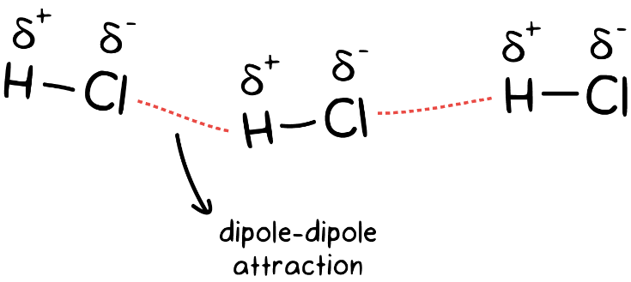
- Dipole-dipole interactions: These forces occur when the partially positively charged part of a molecule interacts with the partially negatively charged part of the neighboring molecule. The prerequisite for this type of attraction to exist is partially charged ions—for example, the case of polar covalent bonds such as hydrogen chloride, HCl. Dipole-dipole interactions are the strongest intermolecular force of attraction.

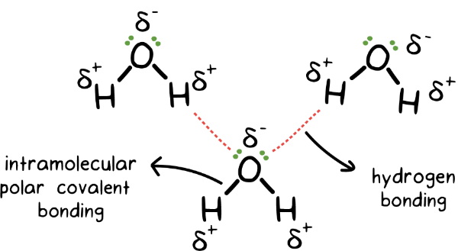
- Hydrogen bonding: This is a special kind of dipole-dipole interaction that occurs specifically between a hydrogen atom bonded to either an oxygen, nitrogen, or fluorine atom. The partially positive end of hydrogen is attracted to the partially negative end of the oxygen, nitrogen, or fluorine of another molecule. Hydrogen bonding is a relatively strong force of attraction between molecules, and considerable energy is required to break hydrogen bonds. This explains the exceptionally high boiling points and melting points of compounds like water, H2O, and hydrogen fluoride, HF. Hydrogen bonding plays an important role in biology; for example, hydrogen bonds are responsible for holding nucleotide bases together in DNA and RNA.
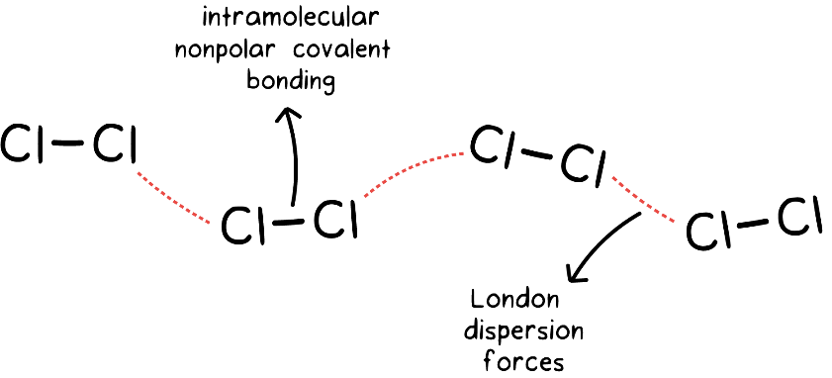
- London dispersion forces, under the category of van der Waal forces: These are the weakest of the intermolecular forces and exist between all types of molecules, whether ionic or covalent—polar or nonpolar. The more electrons a molecule has, the stronger the London dispersion forces are. For example, bromine, Br₂, has more electrons than chlorine, Cl₂, so bromine will have stronger London dispersion forces than chlorine, resulting in a higher boiling point for bromine, 59C, compared to chlorine, –35C. Also, the breaking of London dispersion forces doesn’t require that much energy, which explains why nonpolar covalent compounds like methane—CH₄ and nitrogen—which only have London dispersion forces of attraction between the molecules—freeze at very low temperatures.
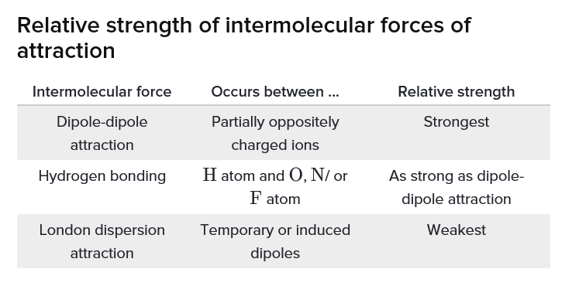

How forces of attraction affect properties of compounds
Polar covalent compounds—like hydrogen chloride, HCl, and hydrogen iodide, HI—have dipole-dipole interactions between partially charged ions and London dispersion forces between molecules. Nonpolar covalent compounds—like methane CH₄ and nitrogen gas, N₂—only have London dispersion forces between molecules. The rule of thumb is that the stronger the intermolecular forces of attraction, the more energy is required to break those forces. This translates into ionic and polar covalent compounds having higher boiling and melting points, higher enthalpy of fusion, and higher vaporization than covalent compounds.
Boiling and melting points of compounds depend on the type and strength of the intermolecular forces present, as tabulated below:

