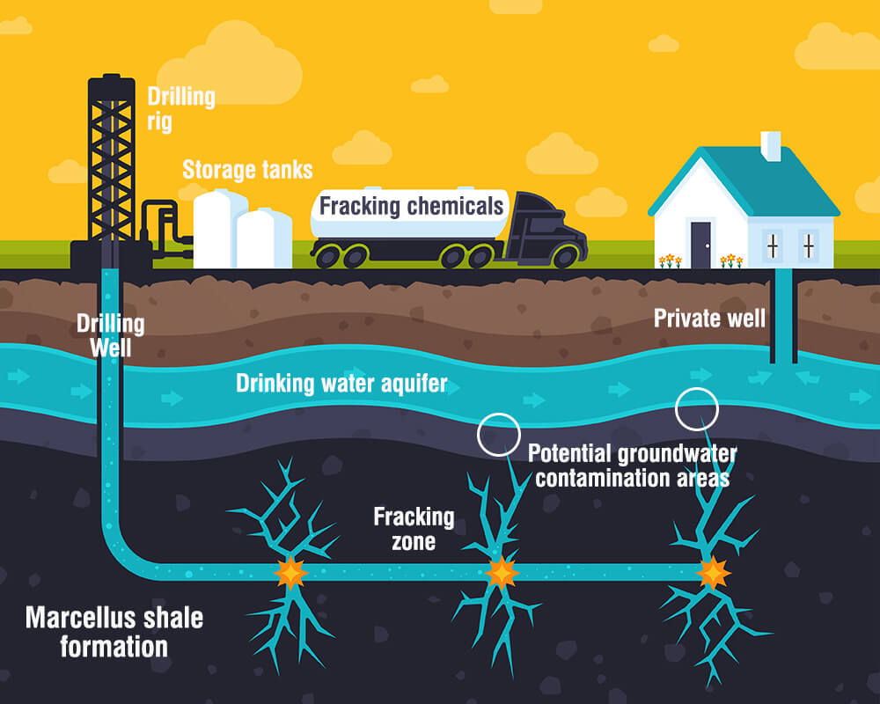
Fracking: Friend or Foe?
https://youtu.be/6qKadxyMOYY

Engage: What is Fracking Video?

On the white boards, answer these questions from your table groups.

- What surprised you about fracking?

- What was the most interesting information?

Explore: Article Annotations “Quit dragging Feet on Fracking” Chicago Sun Times

1st Reading: Look for vocabulary words. Circle them and write them below. I will write them on the board.

2nd Reading: Annotations. Make 3 annotations: 1. Write “+” if the information is an advantage of fracking 2. Write a “-“ if the information is a disadvantage of fracking 3. Write “!!!!” if you feel the info is interesting. Also, highlight the info that you have marked.

Fill in the T-chart below using the movie and the article

Let’s Do It | Forget It

Explain: Video “Light your Water on Fire”

After watching the video, write a 5-7 sentence position summary using the T-chart with the positive and negative information. You must use evidence from your t-chart. You must also state an opposing position to refute it. Be sure to use the vocabulary works and transition words like “Although” and “However”.
https://youtu.be/GJL5M6tAHEE

