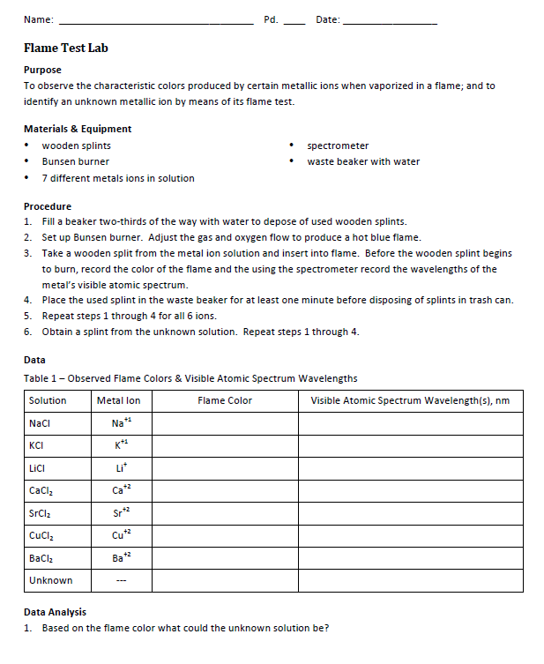

2.
Ion | Electron Configuration | What noble gas does it look like?

3. Draw the Bohr diagram of potassium and show (like in class) how the electron “jumped” and what happens when is “goes back home”.

4. Why does the electron go back to a ground state configuration?

