ENSO Vocab
Term | Definition | drawing | Term | Definition | drawing
El Nino |  |  | thermocline
Trade Winds |  |  | Food chain
Enso Notes
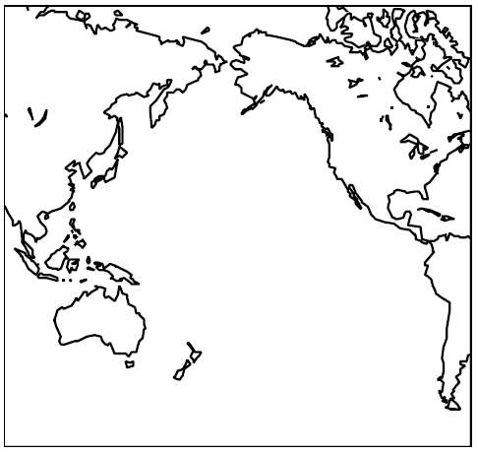
Where?

Walker Circulation

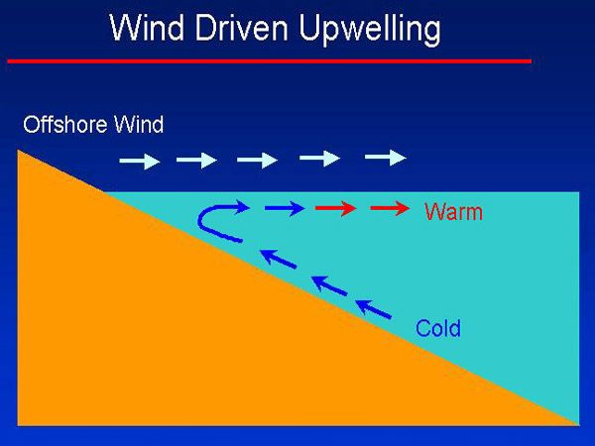

Upwelling

Enso Drawings

Normal year(include trade winds, thermocline, warm & hot water, upwelling, rain cloud)

El nino Year(include trade winds, thermocline, warm & hot water, upwelling, rain cloud)

La Nina year(include trade winds, thermocline, warm & hot water, upwelling, rain cloud)

Enso & America
Draw the pattern based on the powerpoint (use color)and then describe in words this pattern. Include specific states names.
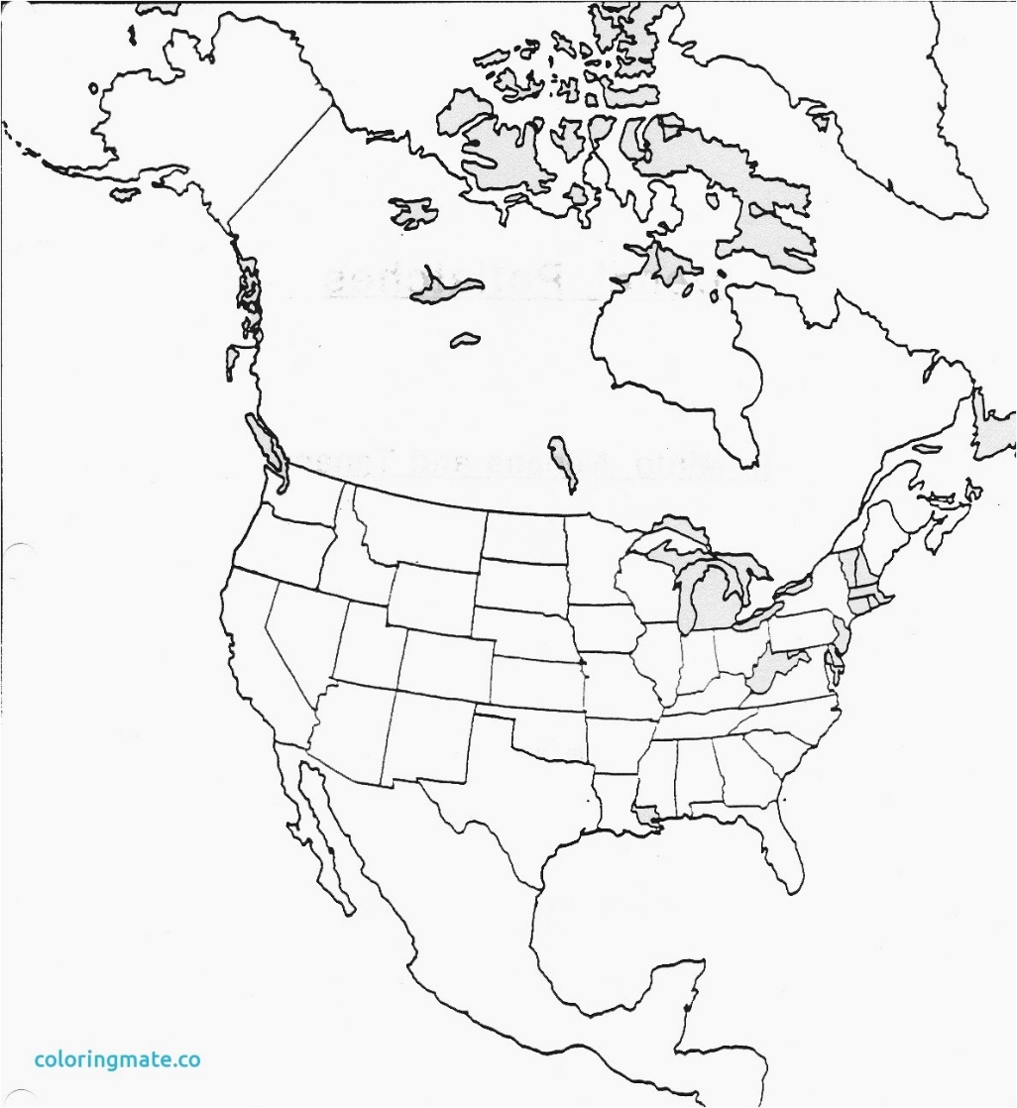

Research
Answer the following questions using your phone

- El Nino has ramifications on the United States. Explain the general effects El Nino has on the USA.

- Describe the difference between the weather in the winter in a normal year and an El Nino year in Peru. Identify 2 ways that El Nino weather endangers people and/or the environment.

- Describe the difference between the weather in the winter in a normal year and an El Nino year in Australia. Identify 2 ways that El Nino weather endangers people and/or the environment.

- Explain the effects of El Nino on Pacific Sea Life & productivity (food chains).

- Based on the graph on page 9, what decade has had the most El Nino events since 1950?

- If El Nino events occurred more often, describe what would happen to the coastal areas of the United States.

ENSO: ________ ________ _______________ ________________
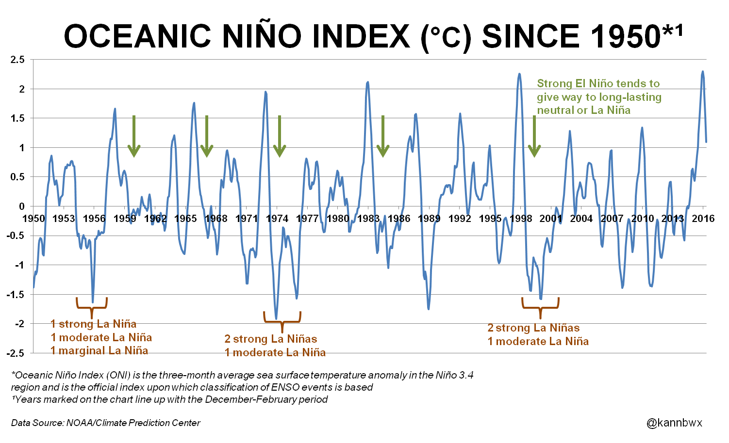

The Nino!
