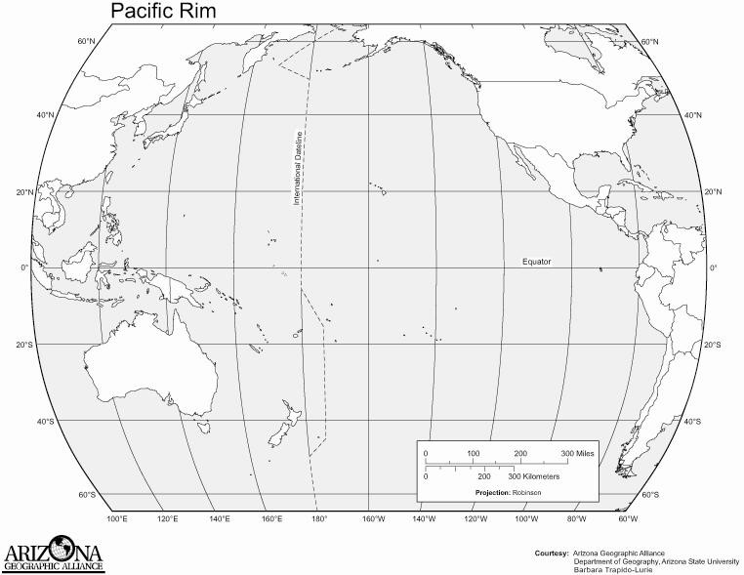
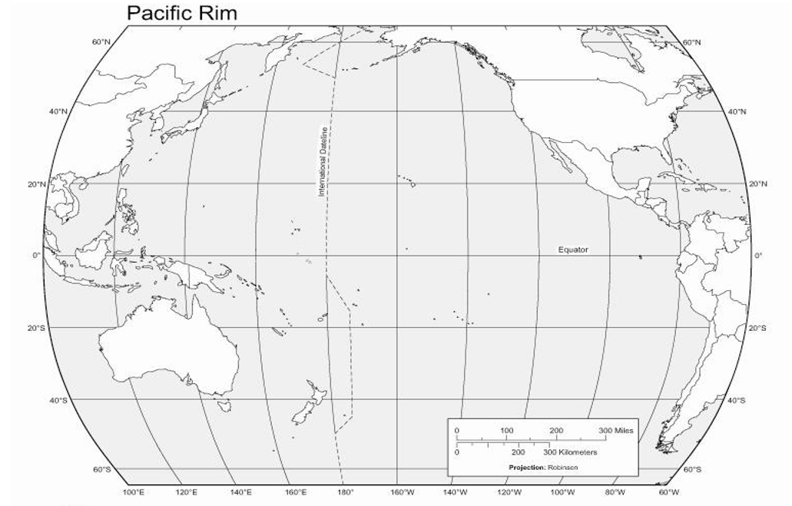

Mapping the Ring of Fire (part 1)

- Using a yellow pencil on a map of the world make a prediction and shade the areas where you think the most earthquakes occur.

- Using an orange pencil on a map of the world make a prediction and shade the areas where you think the most volcanoes occur.

- Label each of the following in brown: o North America continent o South America continent o Australia continent o Asia continent o Pacific Ocean o Sea of Japan o Mt Rainier o Mt Fuji

- Outline and Label the following in green:
o United States of America
o Japan

Use the information in the data table on the next page to mark the location of each earthquake on the world map that follows the data table.

- Use a blue colored pencil to draw a circle at each earthquake location.

- Use a purple colored pencil to mark the locations of the volcanoes on the map with a triangle.

Earthquakes
Volcanoes
Longitude Latitude Longitude Latitude  120° W 40° N 125° E 23° N  110° E 5° S 30° E 35° N  77° W 4° S 140° E 35° N  88° E 23° N 12° E 46° N  121° E 14° S 75° E 28° N  34° E 7° N 150° W 61° N  74° W 44° N 68° W 47° S  70° W 30° S 175° E 41° S  10° E 45° N 121° E 17° N  85° W 13° N | Longitude Latitude Longitude Latitude  150° W 60° N 37° E 3° S  70° W 35° S 145° E 40° N  120° W 45° N 120° E 10° S  61° W 15° N 14° E 41° N  105° W 20° N 105° E 5° S  75° W 0° 35° E 15° N  122° W 40° N 70° W 30° S  30° E 40° N 175° E 39° S  60° E 30° N 123° E 38° N  160° E 55° N

Mapping the Ring of Fire (part 2)
View a map of seismic data from the Pacific Northwest.
- After viewing the data, make a claim (write it on a notecard) and sketch the plate boundaries in the Pacific Northwest with a red pencil.

View a map of seismic data from Southeast Asia.
- After viewing the data, make a claim (write it on a notecard) and sketch the plate boundaries in Southeast Asia with a red pencil.

View a map of seismic data from the Pacific Rim.
- After viewing the data, make a claim (write it on a notecard) and sketch the plate boundaries with a red pencil.

After you have sketched your inferred boundaries, compare your map to a map of the plates of the Pacific Rim

Draw in and label the following plate tectonic structures in black:
    - North American Plate
    - Pacific Plate
    - East Pacific Rise
    - Juan de Fuca Plate
    - Aleutian Trench
    - Philippine Plate
    - Cocos Plate
    - Nazca Plate
    - Eurasian Plate
    - Japan Trench
    - Australian Plate
    - Marianas Trench
    - Peruvian (Atacama) Trench

