Guided Note Questions Name: ________________________
Day 2 – Biomes & Climate
Directions: Please answer each of the following from the notes.
- Describe the difference between weather and climate.

- How does solar energy cause wind to occur? List 2 things that wind carries.

- True or false. Heat is absorbed and released more slowly by land than water. What does this create?

- What land form interrupts winds and movement of storms?

- Sketch the rain shadow effect here.

- Describe how cities create a “microclimate”.

- Draw the “Effects of Elevation and Latitude on Climate and Biomes”.

- What are characteristics of a fragile ecosystem?

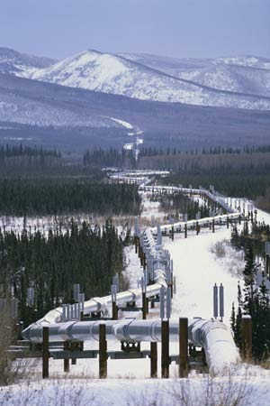
- Why would the tundra be considered a fragile ecosystem?

